**Implementing and running CO model in g-CTMQC code using OpenMOLCAS for electronic structure calculations**

**Introduction**

My project involved running electronic structure calculations in OpenMOLCAS to find Potential Energy Curves(PECs) for singlet carbon monoxide for a variety of CO bond lengths along with Non-Adiabatic Couplings (NACs). The results of these calculations were then implemented into the g-CTMQC code for dynamics calculations. However, the main goal of the project was not necessarily to learn anything about CO, rather, the goal was to gain experience with new electronic structure and dynamics software.

Overall, my current research interests are in exploring Nuclear Quantum Effects (NQEs), and towards the end we will likely be developing our own methods or codes for running dynamics with NQEs. As a result, I will need some experience with other codes to provide comparisons and benchmarks. Furthermore, we are interested in exact factorization methods, thus the g-CTMQC code which implements this is of particular interest. Therefore, while CO is chosen as the model, the overall goal is to grow comfortable with utilizing these methods for future comparisons with the methods we develop.

Finally, the use of the g-CTMQC code for my own molecule that is not currently implemented in the package is that the code currently does not have and interface with electronic structure software. Therefore, it provides another opportunity for me to learn other software from this workshop and hands-on experience with parameterizing adiabatic and diabatic states and programming them into the g-CTMQC package. As mentioned, previously, the OpenMOLCAS package will be utilized for the electronic structure calculations, and the resulting surfaces will then be coded into the g-CTMQC code providing me with some useful experience in both packages.

**Methods**

The electronic structure calculations were carried out in OpenMOLCAS using CASSCF and the CASPT2 level of theory. The ANO-R3 basis set was used and the active space was chosen to be (10,11) (electrons,orbitals). This is similar to active spaces common in literature for CO (usually the full valence (10,8))1 with a few extra virtual orbitals that come close in energy to the HOMO-LUMO gap at large CO bond lengths. The NACs were computed near the coupling region the range of 2.0-2.3 Å.

The results from the electronic structure calculations were plotted and fitted in Maple 2019. For the adiabatic surfaces, generic morse potential functions were used and a linear fit was performed on the NACs. Using the NACs, the overlap angle in the adiabatic to diabatic transformation matrix was calculated according to:

$∇α=-F_{12}$ (1)

where alpha is the mixing angle and F12 is the NAC as a function of nuclear coordinate R(which is CO bond length for this problem). In the 1-Dimensional case, this is easy to solve for alpha analytically and gives us alpha for the transformation matrix:

$S=\left[\begin{matrix}cos⁡(2α) & sin⁡(2α) \\ -sin⁡(2α) & cos⁡(2α)\end{matrix}\right]$ (2)

finally, we use the matrix **S** in Eq. 2 to convert the adiabatic potential to the diabatic potential and find our diabatic PECs using:

**U**=**S**T**VS** (3)

where **U** is our diabatic potential energy matrix and **V** is our adiabatic potential energy matrix.2 This provides us with the diabatic PECs and couplings that are needed for g-CTMQC.

Finally, after the matrix **U** is properly added to the g-CTMQC code, dynamics simulations were carried out for the collision of carbon and oxygen and CO. The starting position of the wavepacket was 7 bohr compared to the equilibrium bond distance of 2.1322 bohr with an initial momentum of -16 1/bohr. CT-MQC, TSFSH, and Ehrenfest dynamics calculations were carried out with the g-CTMQC code.

**Results**

The ground states energies of the equilibrium geometry at the CASPT2 level of theory were -113.212 Hartrees which agreed well with literature values of -113.13579 Hartrees. Furthermore, the SCF orbitals aligned with the general MO picture of the CO molecule. Based on this comparison, it was assumed that the method and active space would provide the necessary accuracy for this project and there were no significant errors. Furthermore, the PECs followed the expected Morse potential for the dissociation of a diatomic, which was also found in the literature. The adiabatic PECs of the ground and first excited state of CO are given in Figure 1. Notice that for points at longer distances, there is some discontinuity in the behavior of the tail. It should approach an asymptote, however, there are steps at certain points. Upon investigation, it was found that the CASPT2 calculation resulted in significant changes in the weights and coefficients of configurations which is a sign of intruder states and erroneous calculations. The energies were recalculated with an imaginary shift of 0.1 and 0.2 to attempt to resolve this but to no avail. Unfortunately due to time constraints, I opted to remove these points from the final data set as the energies were not correct, the corrected PECs are given in Figure 2.

Figure 1. The adiabatic PECs of CO with the erroneous points at the tail.

Figure 2. The adiabatic PECs of CO with the erroneous points removed from the tail.

The PECs were imported to Maple 2019 where the curve fitting was performed. The results of each fit are given in Figures 3 and 4 along with the equation.

 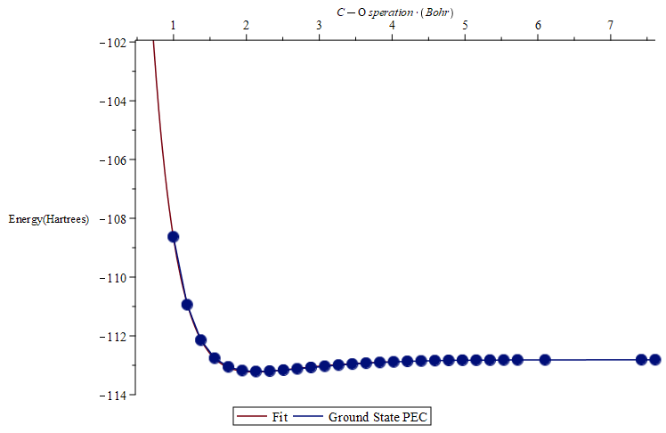

Figure 3: Ground state PEC with fitting function and curve.

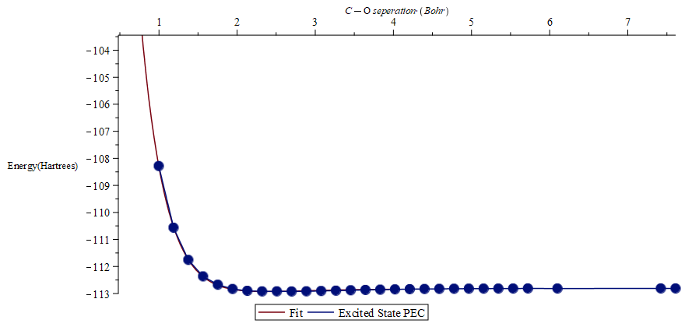

Figure 4: Excited state PEC with fitting function and curve.

Additionally, the NACs and their fit are given below in Figure 5.

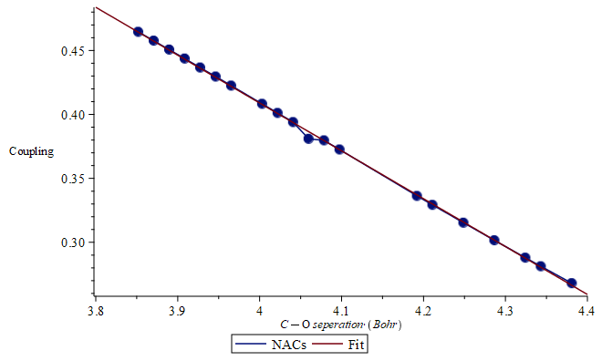

Figure 5. NACs in the range of 2.0-2.3 angstroms along with the fit and function.

The NACs given in Figure 5 appear to continuously grow, however, they are much smaller near the equilibrium distance which was not probed here. It is likely that the sampled range was not large enough and a range needed to be sampled but this was not possible due to time constraints. It should also be mentioned that at first it was assumed that the adiabatic surfaces themselves could be added to the g-CTMQC code without any coupling as that would be calculated by the software. However, it was found that the diabatic states and their couplings were necessary for coupling to be computed at all, as a result, the NACs and the diabatic states were computed much later in the project with far less time to optimize the process. Using these functions and the transformation given in the Methods section, the diabatic states were computed analytically. The functions themselves were quite messy, and so only plots of the diabatic states and coupling are given in Figures 6 and 7 respectively.

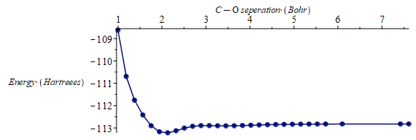

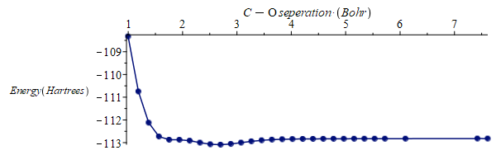

Figure 6. Diabatic ground(top) and excited(bottom) states computed from the transformation.

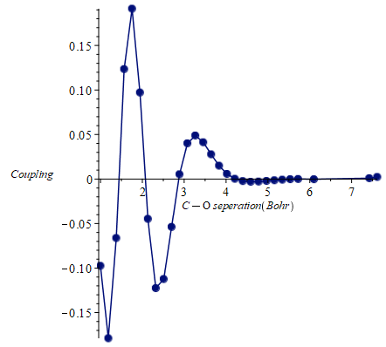

Figure 7. Diabatic coupling computed from the transformation. The behavior towards the smaller internuclear distances may be an artifact of the transformation or NACs as they were not run for the largest range.

Finally, the diabatic surfaces and couplings given above were added to the g-CTMQC code and dynamics could be run. The trajectories on the PECs are given in Figure 8.

CT-MQC

EHREN

TSFSH

Figure 8. Trajectories on the adiabatic PECs of CO

Do to the size of the files, the phase space and populations plots are being omitted from the report. However, a qualitative analysis can be performed on the above data to provide the relevant information. We can first see in general; all methods provide a similar path of the wave packet. From the initial momentum driving the wave packet to the well, we the wave packet pass the coupling region and transfer to the ground state before passing through the well and being then returning to its origin after failing to exit the well on the right. This suggests that as the nuclei come together, then pass their equilibrium bond distance and repel each other and return to their initial distant start. This is likely because there is no energy sink, and after repelling each other, the wave packet is unable to lose the momentum it gains as it passes the equilibrium point and it has enough energy to leave the well on the right and so we do not see a CO molecule form. Potentially, if there was an artificial energy sink to remove excess potential or simulate the heat released in the formation of a bond, we might be able to see the wave packet end in the equilibrium geometry. As well, we can see in general the Ehrenfest and CT-MQC methods follow similar trends, and the trajectories quickly transfer to the ground state in coupling region. Fir the TSFSH method, we see trajectories remain in the excited state for far longer, but they eventually return to the ground state as well. Overall, the adiabatic surfaces appear to have been calculated correctly by the g-CTMQC code, and there are not many major artifacts in the dynamics as the coupling happens in the expected region and the trajectories behave as expected. This suggests that while some parts of the project could certainly be improved (NACs and diabatic states calculation) the results at least reasonable.

**Conclusion**

Overall, it should be restated again that there were multiple parts of the analysis that could be improved. For one, more points and a larger range for the NACs would likely provide better diabatic couplings and states, however, since the dynamics are run on the adiabatic states, this issue does not affect the results to significantly, although the couplings could likely be better, and this may remove some artifacts of the calculation. Additionally, the CT-MQC calculations themselves could be ran with more trajectories or for longer times. Regardless, due to time-constraints, these points are unable to be addressed, and a proper exploration of diabatic transformations, NACs and other initial conditions for the dynamics were unable to be explored in this project. However, the obtained results are still reasonable, despite the shortcomings of the methods. Finally, the overall goal of the project was not to obtain publishable results of dynamics on CO. The main objective was to use and gather experience with the g-CTMQC code and OpenMOLCAS, and to this end the project was successful.

**References**

1. Peterson, K. and Woods, R., 1990. Theoretical dipole moment functions involving the a 3Π and a’ 3Σ+ states of carbon monoxide.  *J. Chem. Phys.*, 93(7), pp.5029-5036.
2. Köppel, H., 2004. DIABATIC REPRESENTATION: METHODS FOR THE CONSTRUCTION OF DIABATIC ELECTRONIC STATES. *Advanced Series in Physical Chemistry*, pp.175-204.